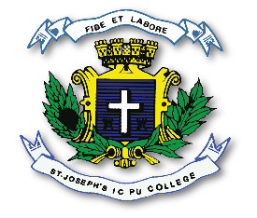
ST. JOSEPH’S INDIAN COMPOSITE PU COLLEGE
#23, Vittal Mallya Road, Bangalore – 560001.

SUBJECT: CHEMISTRY (34)
I PUC
PORTIONS FOR I TEST – 2023-24

TOPICS
SOME BASIC CONCEPTS OF CHEMISTRY
BASIC PRINCIPLES OF ORGANIC CHEMISTRY – upto hyperconjugation effect (12.7.9)
CLASSIFICATION OF ELEMENTS AND PERIODIC PROPERTIES
.

